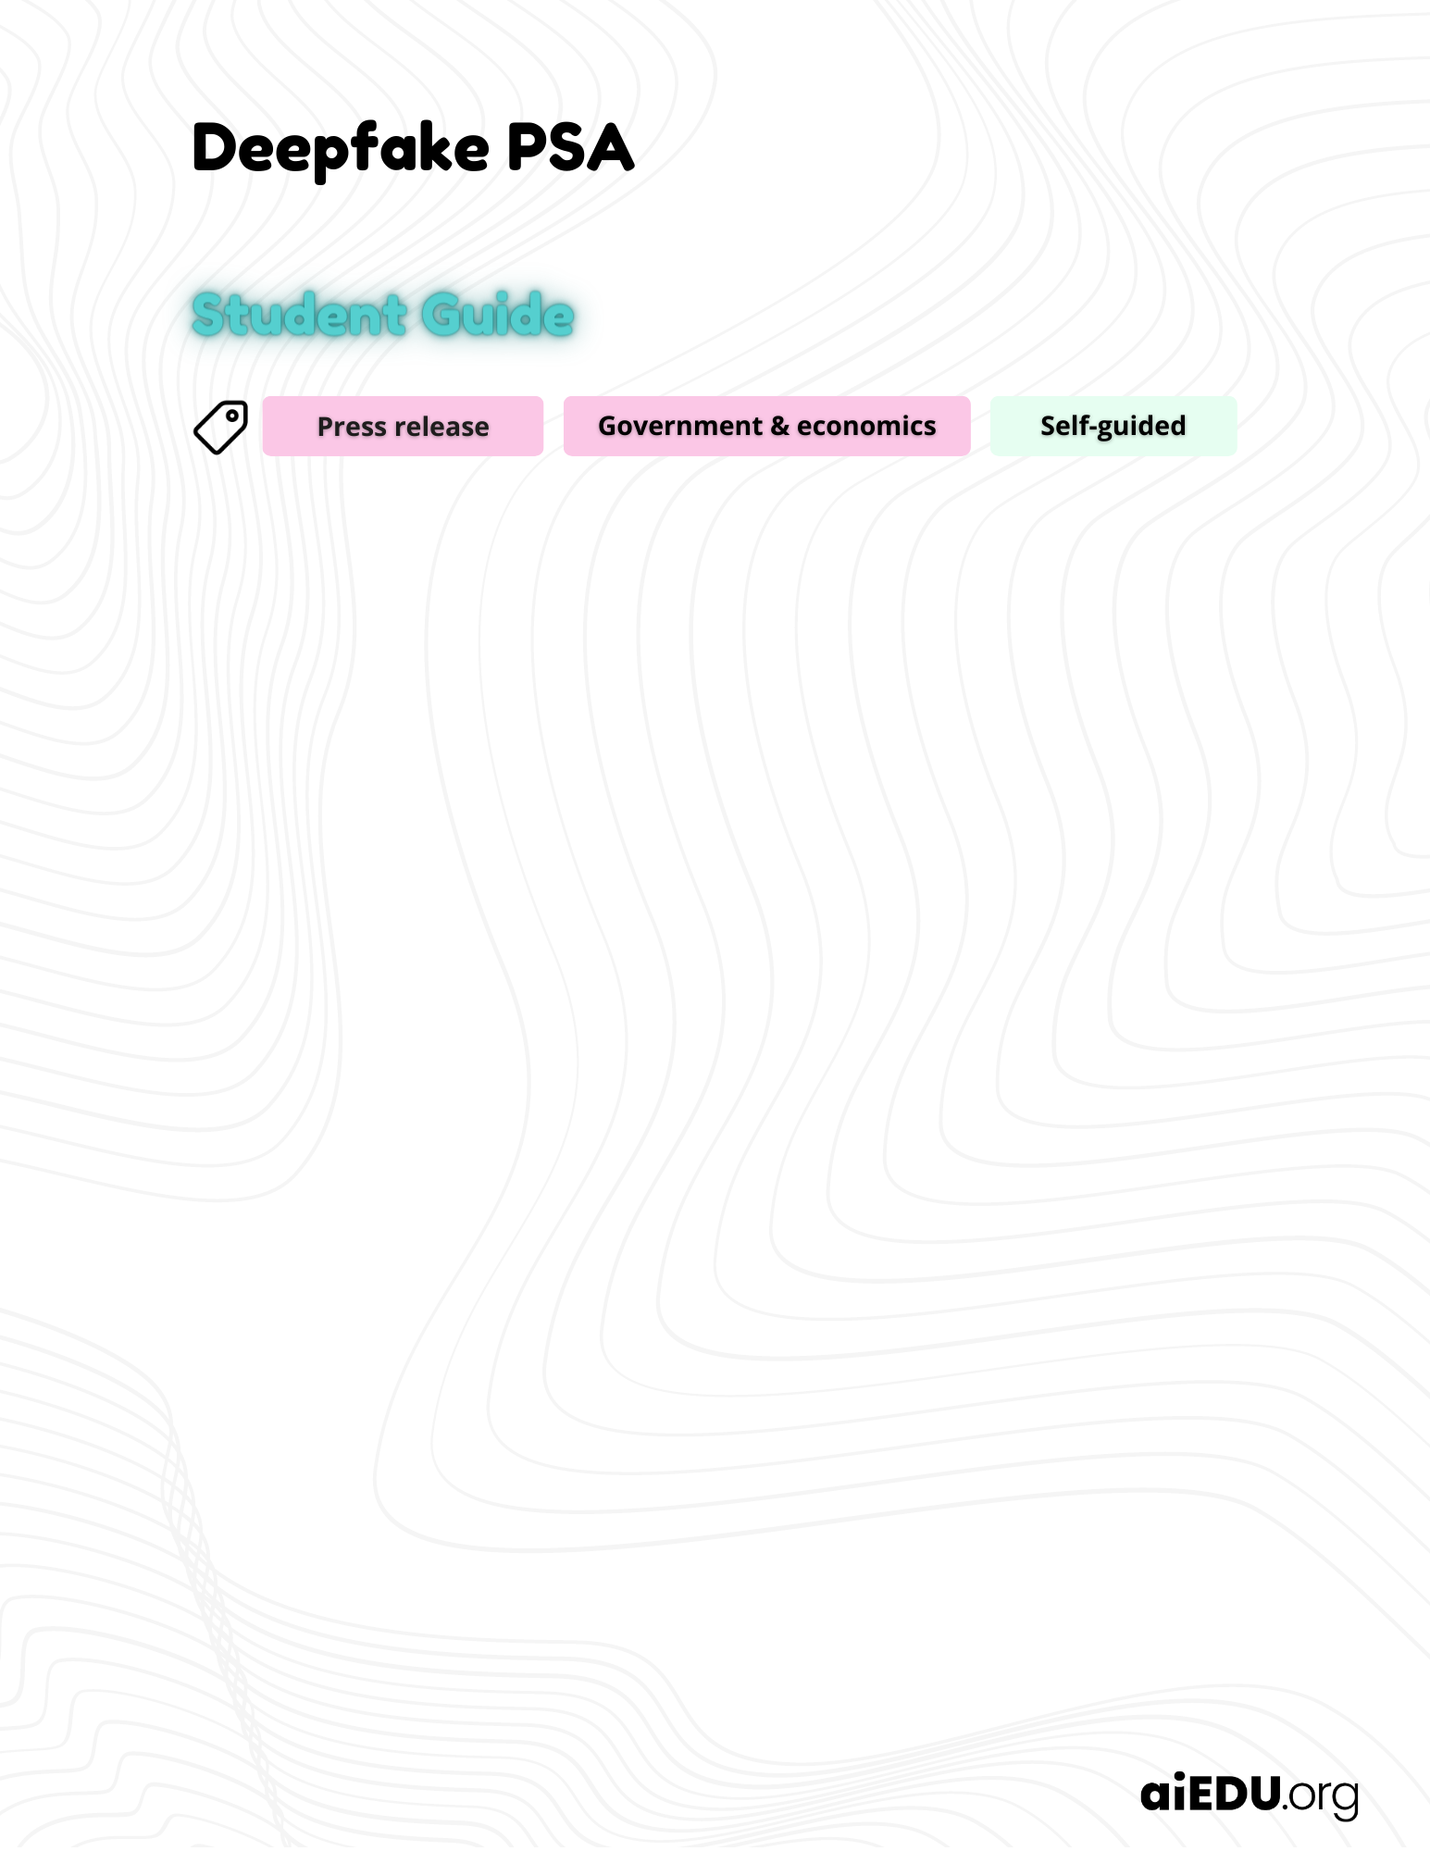

Add your answers in the green boxes below.

Find the deepfake
 | One of these photos is real and one was generated by AI. Use the dropdown menus under the photos to identify which image is the fake.
   | 
  Choose one | Choose one
 | How do you know?

 | The definition of artificial intelligence (AI)
Check out the definition and interesting examples of AI at
🔗 aiedu.org/ai-in-five. Make sure to read the page before moving on.

The definition of deepfake
A fake piece of media, like an image or video, that is created by using AI to manipulate existing images, videos, and/or sounds.

Deepfakes are often deceptively realistic so it can be extremely difficult for humans to tell that they are fake.

The definition of press release
Press releases are official releases from an organization regarding specific news, issues, or events. White House press releases are those that are created and distributed by the office of the president. The purpose of a press release is to inform the public about some important topic or event.

Deepfakes and democracy
Deepfakes impact on political systems
In this project, you will be writing a White House press release that informs the American public about the potential benefits and harms of deepfakes. First, you must consider why it is important for the public to learn about deepfakes, especially as they relate to the American political system.

The term “fake news” is used often to describe incorrect information (disinformation) that is widely distributed. Disinformation can influence the way voters see themselves and the issues they care about. Deepfakes are a type of disinformation that can change people’s voting habits.

Watch this video to learn more about deepfakes and democracy:
Deep Fakes: How They’re Made and How They Can Be Detected

What is one way deepfakes can have a positive impact on democracy?

What is one way deepfakes can have a negative impact on democracy?

What makes a good press release?
Press release 101
A press release is meant to announce an important and news-worthy story. White House press releases often communicate vital information to the American public. How do you write a press release that catches people’s attention and informs them without being long or boring?

- Know your audience. All writing is better if you know who your target audience is. Who will benefit the most from the information you are writing about?
- Write a clear and attention-grabbing headline. The headline, or title, of your press release must clearly express what the release is about and make a person want to read it.
- Answer the 5 W’s. Outline the who, what, why, when, and where of your topic.
  - What is the news about?
  - Who is involved or affected?
  - When and where did it happen?
  - Why is it important?
- Add detail. Give your readers the important details without overwhelming them with unnecessary information. Readers can seek out more information if they want to.
- Write a conclusion. End the press release with a short conclusion that summarizes the important information and offers plans for next steps.

Press release samples
Read through both of the following press releases:
- Press Release #1
- Press Release #2

In your opinion, which press release is more effective? Why?

Create a White House press release
Press release outline
Use this Press Release Outline template to plan your White House press release.

Your outline should include:
- A clear and catchy headline
- The 5 W’s for your introduction
- At least 3 important details you want to include to support your point
- Two summarizing statements that will go in your conclusion

Write your own press release
Use the White House Press Release template to write your press release.

Your press release should:
- Be between 250 - 400 words
- Have a clear and descriptive headline
- Have at least 3 paragraphs:
  - An introduction that introduces the topic and clearly explains the who, what, where, why, and when.
  - A middle paragraph that includes important additional details
  - A conclusion that summarizes the release and describes next steps

Do you think this press release would make a big difference in combating fake news? Why or why not?"



